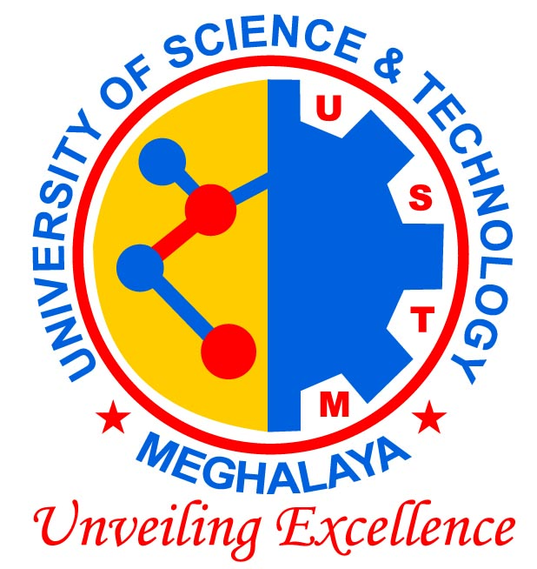
University of Science & Technology, Meghalaya
Techno-City, Kling Road, Baridua, Meghalaya – 793101

Workshop on IPR conducted by SBUS in association with Tezpur University

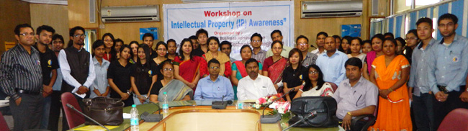

The department of Business Administration of USTM in association with the IPR cell of Tezpur University conducted a day long workshop on “Intellectual Property Rights Awareness” on 4th April, 2015. The coordinator and the research officer of the IPR cell of Tezpur University Dr. Pritam Deb & Dr. Suchibrata Goswami were the resource persons of the workshop.
The workshop started with a inaugural sessions which was attended by Dr. R. K. Sharma, Pro Vice Chancellor, USTM and Prof Alaka Sarma, Dean Student affairs and Welfare.
The opening session elucidating the purpose of IP, and giving an overview on the most important IPRs, such as, patents, trademarks and trade names, designs, copyright, etc. Illustrative examples were discussed to explain the various intellectual property rights issues. The sessions specifically focus for patents (protecting technical inventions), including topics such as the patentability criteria, the contents of a patent application, how patents can be exploited, were proposed. All these topics were accompanied with illustrative examples. Furthermore, the participants got an introduction to claim interpretation, drafting, overview on searching patent literature, and Do’s and Don’ts again accompanied by illustrative examples.
Dr. Pritam Deb highlighted the following points:
• Innovation the way forward for India in the 21st century.
• Problems and challenges in IPR
• The 4 p’s to Intellectual property i.e. Promises to Practice to People at Purchasable Prices.
• Emphasis was put on what makes some goods/ services sell more than others.
• The importance of Innovation was elaborated.
• The resource persons gave a detailed explanation regarding how to protect innovation in the market.
• He further explained the concepts of innovation process, output and market in Intellectual Property Rights.
• Institutional intellectual property management was focus on and how benefits can be derived from it was highlighted.
• The role and importance of Institutional IPR cell in protection of IP was emphasised.
• The resource person elucidated the problems regarding IP in India.
Dr. Suchibrata Goswami highlighted the following points in her Session:
• How intellect becomes property?
• What is intellectual property?
• IP as a property
• How to manage the IP as Property.
• Details were given regarding the various forms of IP present.
• Patents, Trademarks, Service Marks, Geographical Indications, Copyright were elaborately discussed with detail examples.
• IP criteria, the contents of a IP application, how IP can be exploited were discussed

