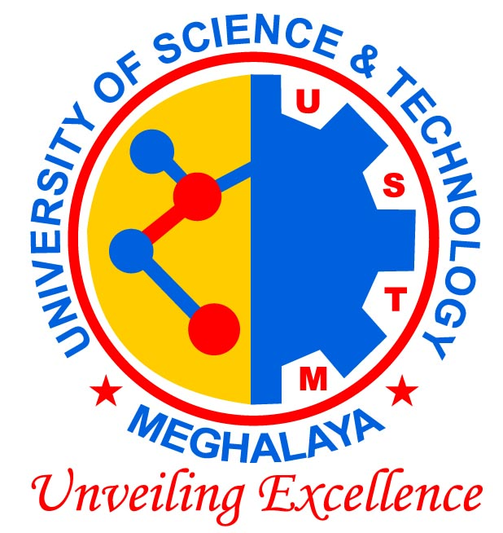
University of Science & Technology, Meghalaya
Techno-City, Kling Road, Baridua, Meghalaya – 793101

Bio-Science experts moot special IPR core group for North East

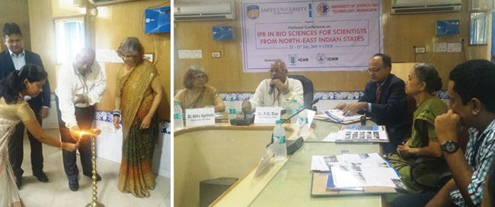

GUWAHATI, JULY 23: Bio Science experts and technocrats from across the country who had gathered for the three day National Conference on ‘IPR in Bio Sciences for Scientists from North East Indian States’ at the University of Science & Technology Meghalaya (USTM) were unanimous in their resolution that a special core group be set up for creating awareness about IPR in the North Eastern States of India so that students, researchers, scholars and all other end users of technology could derive maximum benefit from it. This resolution came during the valedictory session of the Conference held on Thursday. In his presidential remarks, Dr. P. G Rao, VC of USTM suggested that the core group could function from Guwahati and experts from ICAR, ICMR, Central-State-Private universities could be its members.
On the concluding day, Dr Shashank Mauria, Additional Director General, ICAR New Delhi, deliberated on ‘Intellectual Property & Technology Management in Agriculture – Indian Perspective.’ He explained the economic values of different ecosystem services and efforts of ICAR in the endeavour for cataloguing these values.
Dr Pritom Deb, Coordinator of the IPR Cell at Tezpur University, spoke on “Weaving Intellectual Property Rights in Creativity, Knowledge Creation, Innovation, & Technology Management.” He gave a detailed description of the initiative undertaken by Tezpur University in ensuring IPR of the muga and mukha designs of North Lakhimpur District of Assam.
Dr. Jyoti B Dutta, Assam Agricultural University; Dr Abha Agnihotri, Amity University, UP; Dr Amit Kharkwal, AIMT; Dr KK Singh, AIALS; and Dr Mukul Kumar, Central Agricultural University, Pasighat also spoke on the concluding day of the Conference. The proceedings came to an end with the deliberations from Dr Manas Jyoti Nath, Palme Borthakur, and Samikhu Changmai, faculty members at USTM.

